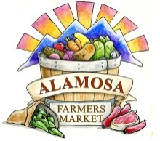
Alamosa Farmers’ Market Ask Me About

Please Clearly Print the following information:
Organization Name:
Contact Person Name:
Name of Person/ people staffing the booth:
Mailing Address:
City, State, Zip:
Phone (Cell):
Phone (Other):
E-mail:
Website/ social media handles:
Describe your organization:

Do you have special requests for your booth? (Electricity, second table, dunk tank, trained elephant, etc.)

Other notes or questions:

I would like to have an “Ask Me About” Booth for the following dates:
(Number your top 3 choices of dates)
July 25 | August 1 | August 8
August 15 | August 22 | August 29
September 5 (Labor Day Weekend) | September 12 | September 19
September 26 | October 3 | October 10
Please return to Alamosa Farmers’ Market asap.

