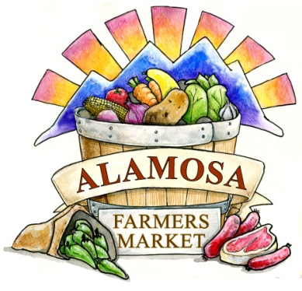

May 14, 2025
Hello Farmers’ Market Family!

Welcome to the 2026 Alamosa Farmers’ Market Season, our 46th season and my last with the Alamosa Farmers’ Market. This vendor packet is smaller this season because we are shifting to on-line registration. You will find out more information about that and other changes to the market at the pre-season vendor meetings this June. More on that in point 5. In the meantime, here is what you need to know about the 2026 season:

- Alamosa Farmers Market Contact Info:
Mandy Pittman, Director (until November 2026)
Email: alamosafarmersmarket@gmail.com
Phone: 719.849.1083
Website: alamosafarmersmarket.org
Facebook: https://www.facebook.com/alamosafarmersmarket
Instagram: @alamosa_farmers_market

- Market Times: Saturdays, 8 am to 1:30 pm (No early departures)

- Market Dates: July 11 to October 10 (14 weeks)

- Market Location: Corner of Ross Avenue and 6th Street/Highway 160 in Downtown Alamosa

- Vendor Pre-season Meeting: All Vendors should attend one pre-season vendor meeting. Vendors who attend this meeting will be entered into a drawing for free booth fees for the season (Application fee and commission rates still apply). Vendor materials will be distributed at this time. If you are unable to attend, fill out this form: https://forms.gle/Xbb6nkT6wxsLZQtg8
- Wednesday, June 10, 6 – 7:30 pm
- Friday, June 12, 5:30 – 7 pm
- Saturday, June 13, 10 – 11:30 am
All Meetings at “The Hub” 516 San Juan Avenue, Alamosa

- Dogs: Vendors are discouraged from bringing their dogs to the market. If you choose to bring them with you must check with the staff ahead of time and complete the vendor dog form.

- Forms of acceptable payment to Vendors:
    - All Vendors: Cash and Market Bucks
    - Approved Vendors: SNAP, Double Up Food Bucks
    - Vendors may also choose to use digital payments like Square, Venmo, etc. if you wish
    - Vendors will be reimbursed for all vouchers at the end of the market day

- Market Fees:
- Vendor Application fee (Once per season) - $30, All Vendors
- Booth Fees
  - 10x10 space, without vendor vehicle, Weekly: $12
  - 10x10 space, with vehicle, Weekly: $20
  - Oversized space (larger than 10 feet), Weekly: $30
  - Food Truck Spot (Booth space, 1 electric plug, no commission due), Weekly $45
- ***Discounts for monthly and season reservations, for approved vendors***
- Commission – 5% of sales – This is an increase from 3% from 2025
- Electricity - $5 per week per plug
- Fines:
  - $15 – Unannounced vendor fine
  - $10 – Late arrival fine
  - $20 – Early departure fine

- On-line Registration:
  - We are introducing on-line vendor registration for 2026 at alamosafarmersmarket.org
  - This will allow annual registration to be more streamlined going forward

- Becoming a Vendor for 2026:
    - Register on-line (If that is not an option, you can request a paper application).
- Pay all necessary fees either on-line or with a check, before your first market.

- What’s app
- We are asking all vendors to join this app so we can communicate with you all easier.
- Vendors not using What’s app should alert staff so we can be sure you receive all relevant communication.
- This app will be used to alert vendors to weather related market impacts as well as any information that needs to be communicated quickly.

We are so excited for this season and to celebrate 46 years of serving the Alamosa and San Luis Valley Community! In addition to this letter, this vendor packet includes our Rules and Regulations and our sponsorship forms. We are in need of funds from our local community so if you know of a business or organization that would like to support the market, please share this. Its also on our website. We are accepting monetary and in-kind donations at this time.

Can’t wait to see you all in June for our vendor meetings!

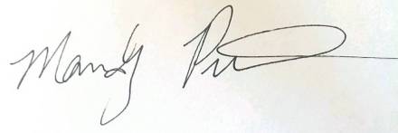
Mandy Pittman
Alamosa Farmers’ Market Director

