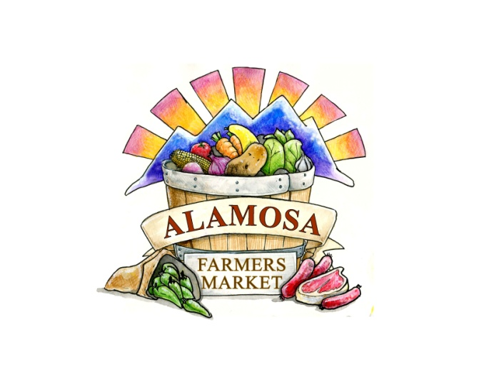

April 4, 2023

Hello Farmers’ Market Family!

We are so pleased and thankful to welcome you back for the 2023 season! Here’s the rundown for our upcoming season:

1. **Market Times**: Saturdays, 8 am to 1:30 pm
2. **Market Dates**: July 8 to October 14 (15 weeks this year)
3. **Market Location**: NEW LOCATION!!! Corner of Ross Avenue and 6th Street/Highway 160 in Downtown Alamosa (It will be a newly constructed parking lot)
4. **Forms of acceptable payment to Vendors**:
   * + All Vendors: Cash and Market Bucks
     + Approved Vendors: SNAP, Double Up Food Bucks, WIC Vouchers
     + Vendors may also choose to use digital payments like Square, Venmo, etc. if you wish
     + Vendors will be reimbursed for all vouchers at the end of the market day
5. **Market Fees:** Market Insurance $10 per season

* Booth Space $15 with vehicle/ $12 without vehicle
* Vendors needing more than 10 feet of space will be charge for more than one booth.
* ***Discounts for monthly and season reservations, for approved vendors***
* Commission – 3% of sales
* Electricity - $5 per week per plug

1. **ALL VENDORS ARE REQUIRED TO USE TENT WEIGHTS**

* Instructions are enclosed.
* This is a mandatory requirement going forward. It is getting windier in the afternoons. All tents need to be anchored to a weight or your vehicle.

1. **Becoming a Vendor for 2023**:
   * + Complete the Vendor Contract; fill out all the spaces, please

* Do not include payment, you will be contacted about payment
* No refunds for advance payment
* If you want to use electricity, fill out the enclosed “Request for Electricity” Form
* Craft vendors will be able to reserve a space for weekly or monthly only. (Craft vendors are vendors who are offering non-food items for sell and those items make up more than 50% of what the vendor is selling).

1. **Special Notes:**

* Food vendors can provide samples but MUST get clearance from Market Director ahead of time.
* If you want to sell items that you did not list on your vendor contract, you must get approval from market staff ahead of time. *Just because you are an approved vendor does not mean you can sell whatever you want.*
* Prepared food vendors need to have a copy of a current food safety handling certificate on file before they can sell prepared food items. This is for any food you dry, heat, bag, bake or otherwise modify from its original raw state like honey, spices, seeds, etc.
* We have live music scheduled for each week of the season.
* Kids’ activities will again be on-site or take home each week.
* I would like to offer some educational booths this year. Topics I am looking to have are backyard chickens, preserving food, and seed saving. If you have any other topics to suggest or people who are “experts” to recommend, let me know.

You made it! You read my whole letter and are hopefully excited about the 2023 season! Mail in your application by June 1 to secure a spot for the 2023 season!

Mandy Pittman

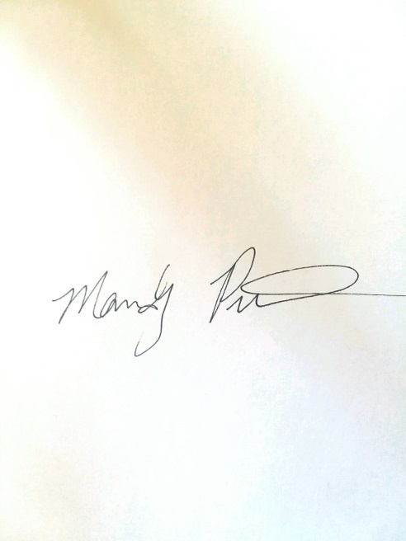

Alamosa Farmers’ Market Director